**RESUME**

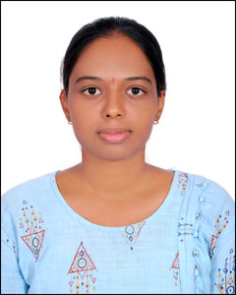

Candidate name: Siripuram Bhavana

Mobile No: 8790936980

Email ID: bhavanasiripuram20@gmail.com

# CAREER OBJECTIVE

To become a significant contributor in an esteemed organization that provides a challenging environment and opportunities to work and to map my potential onto maximum extent.

# ACADEMICS

1. Graduation Details : B.tech in Electrical & Electronics Engineering stream with 74 percent aggregate in Bhoj Reddy Engineering college for Women
2. Senior Secondary : Intermediate in SRR Junior College with 97 percent aggregate
3. Higher Secondary : SSC in St. Mary’s High School with 87 percent aggregate

PROJECTS

1. Did a project on hydro power plant
2. Did a project on Transmission line multiple faults detection and indication to electricity board using GSM
3. Did a project on Sag control by using multilevel inverter based DSTATCOM

# SKILLS

1. Active Listening
2. Patience
3. Leadership Quality
4. Positive attitude

5. Technical Skills: MATLAB, C language, SQL, Basics of Linux, Verilog basics

# ACHIEVEMENTS

1. Achievement 1: achieved 3rd position in smart test at college level conducted by SRM Institute of science and technology
2. Achievement 2: achieved certificate of appreciation in A National Level One Week Online Workshop for

Students on “Fundamentals of MATLAB and Programming”

1. Achievement 3: achieved merit certificate in “Bhoj Reddy Engineering College”

# EXPERIENCE

1. Did an Internship(6 months) in Ericsson Global services on Telecom
2. Currently working as FTE in Ericsson Global services from Sep 22, 2022

# PERSONAL DETAILS

1. Date of Birth: 28/04/2000
2. Father's Name: Siripuram Laxman
3. Mother's Name: Siripuram Jyothi
4. Current Address: 12-45 Vidya Nagar, Mandamarri, Mancherial
5. Permanent Address: 12-45 Vidya Nagar, Mandamarri, Mancherial
6. Hobbies: Playing shuttle, Drawing, Crafts
7. Nationality: Indian
8. Languages Known: Telugu, English
9. Any kind of disability: No

# DECLARATION

I hereby declare that all the above-mentioned information is true and correct to the best of my knowledge.

Place: Mancherial Signature: S.Bhavana